Employee Details: (as per last organization)

|  |  |
| --- | --- |
| Employee Name | Pallapu NaniBabu |
| Employee ID | 103292 |
| Last Organization Name | Innova Solutions Pvt Ltd. |
| Designation(last held) | Associate Software Engineer |
| Date of Joining | 26-April-2022 |
| Date of Relieving | 31st-May-2024 |
| Reason for Leaving | Career Growth |
| CTC(last drawn) | 557,988 (40,429 drawn last month) |
| HR Details  (Name, Mobile Number & Official Mail ID) | Hrishikesh Kaveti  hrishikesh.kaveti@innovasolutions.com |
| Reporting Manager (Name, Mobile Number & Official Mail ID) | Shaik Feroz 81435-78132 feroz.shaik@innovasolutions.com |

Personal Details:

|  |  |
| --- | --- |
| Mobile Number | 93925-90089 |
| Personal Email ID | nanipallapu369@gmail.com |

Address Details:

|  |  |
| --- | --- |
| Current Address Details with Pincode: | SBN PG, Padma Sri Gardens Layout, Gowlidoddy, Hyderabad, Telangana – 500075. |
| Landmark | US Consulate General Hyderabad |
| Period of Stay | 2 months |

|  |  |
| --- | --- |
| Permanent Address Details with Pincode: | 6-48, Hanuman Peta, Uppaluru, Kankipadu Mandal, Andhra Pradesh - 521151 |
| Landmark | Panchayat Office |
| Period of Stay | 3 Years |

|  |
| --- |
| **LETTER OF AUTHORISATION** |

**To Whomsoever It May Concern**

I hereby authorize HTC Global Services India Pvt. Ltd. (HTC) and its authorized representatives to verify information provided in my resume, employment information form and application of employment, and to conduct enquiries as may be necessary, at the company’s discretion. I authorize all person(s)/Company/Organization, who may have information relevant to this enquiry to disclose it to HTC or its representatives, which can be kept confidential. I release all persons from liability on account of such disclosure, of information/data/material facts/any other document or opinion based on my association with them.

I hereby authorize concerned authorities to dispatch my confidential report to HTC or its authorized representatives.

**Note:** Some of our customers’ projects which are highly sensitive in nature may require criminal background checks and other necessary checks carried out before you are assigned to the same. In this connection, and as is the procedure followed by most police departments across India, for criminal background verification, it is possible that police authorities may contact or visit the stated residence and at times even ask to be physically present at the concerned police station. It is part of the standard verification procedure.

**Signed: __________________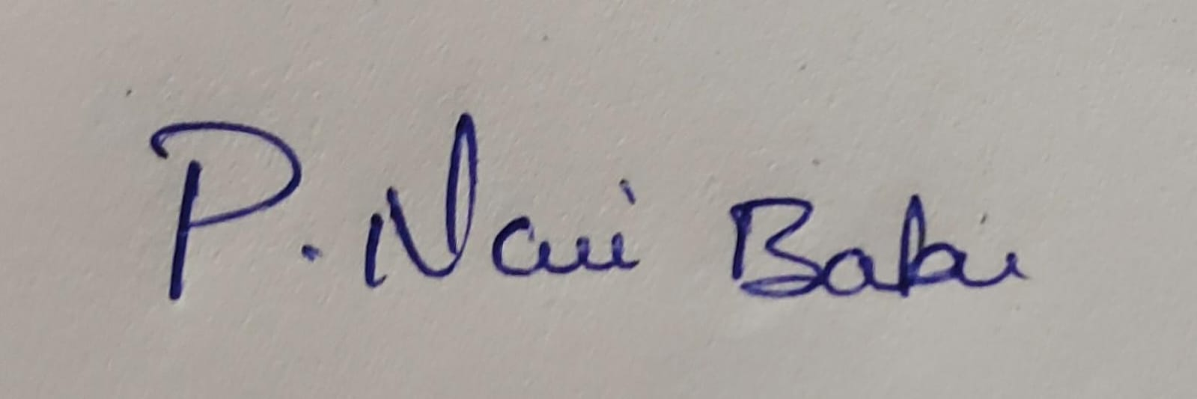____________________**

**Name: _________________Pallapu Nani Babu______________________**

**Date: _________________21-05-2024________________**